Annex:

A. RACMT Efficiency Grant Application Form

7 Dec 2023 V1.2
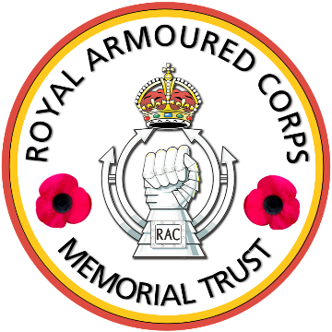 ANNEX A TO
RAC/001/2.2.1
DATED 7 DEC 23
THE ROYAL ARMOURED CORPS MEMORIAL TRUST (RACMT)
APPLICATION FORM FOR A MILITARY EFFICIENCY GRANT

Please do first read our terms for military efficiency grants as to why, what, who and how we fund activities or projects. Your application should be sent by you electronically to Major Robin Wheeler VR at Secretary@racmt.org

1. Activity or Project Name:

2. Name, Rank, Number, Unit, and full contact details of person responsible for leading the Project/Activity:

Name:
Rank:

Civilian/Military Work Phone Numbers:

Home Phone Number:

Mobile Number:

Work Address:

Home Address:

Work Email:

Home Email:

A-1
3. Names, Ranks, Numbers and Units of persons benefitting from your project/activity.
(Note all must be Serving RAC):

NAME | RANK | NUMBER | UNIT
A-2
4. Description of Activity/Project in not more than 50 words:

5. Dates and duration of Activity/Project:

6. Justification or explanation of how your Activity/Project:

a. promotes RAC military efficiency,

b. the benefits that will accrue from it,

c. how it meets our aim and purposes (Max 250 words):

A-3
7. Outline why and for what you need our support (Max 200 words):

8. The total gross cost of your Activity/Project:

9. Total sum of funds raised from other sources including personal contributions:

10. The total sum of the grant you are requesting from us:

11. Any other comments you would like to add to support your application:

A-4
12. If a Club or sport please submit last year’s audited financial report/statement with a copy of your latest bank and if applicable investment statement.

13. Please submit up to 3 letters of support and any images/photographs that will enable us to better understand your application.

14. As Leader or person responsible I confirm that I have read, understood, and accept the terms for receiving a military efficiency grant from the RACMT.

Signature:

Date:

A-5
7 Dec 2023 V1.2

